

pERSONAL sKILLS

Team Swot



27 september 2017

The Akatsuki

Zohair / Ali / Mark / Rudolf / Lesley / Huseyin

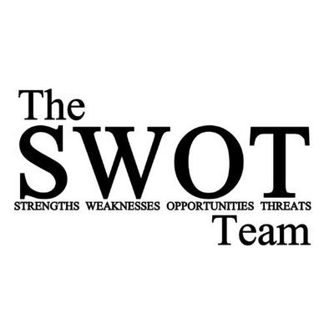

**Sterkte-zwakteanalyse**